Magic finger

A science teacher shows her class how to do a magic trick.
She removes the middle of her finger with a glass block!
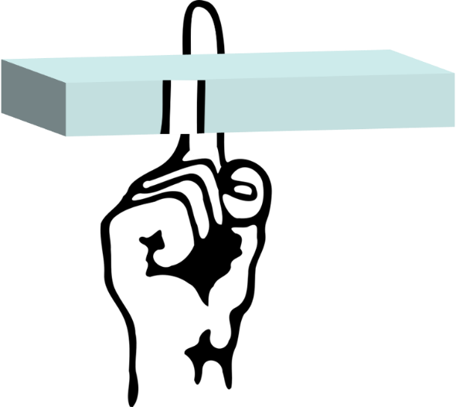

How can you explain the magic trick?
Put a tick (✓) in the box next to the best answer.

A | Light changes direction as it moves through the glass
B | Light changes direction as it enters and leaves the glass
C | The glass moves the image to one side
D | The glass twists the image

Physics > Big idea PSL: Sound, light and waves > Topic PSL3: Making images > Key concept PSL3.2: Refraction and lenses
Diagnostic question
Magic finger

Overview
Learning focus: | All light from each point of an object that passes through a converging lens is bent (refracted) to a corresponding point in a sharp image.
Observable learning outcome: | Recall that light can change direction (refract) when it passes across a boundary between transparent media.
Question type: | Simple multiple choice
Key words: | Refract, refraction

What does the research say?
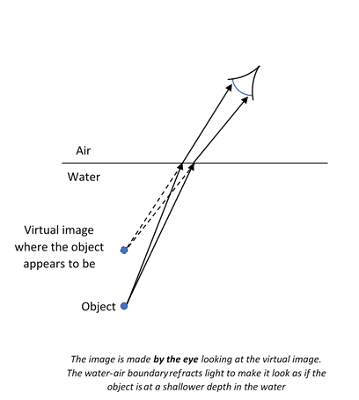
A common strategy for teaching students about refraction is to demonstrate examples of refraction phenomena and to explain the observations using ray diagrams that show how light is bent by glass blocks. In this approach students may use a ray box to explore how light travels through a parallel sided glass block to understand the nature of refraction. They change the angles of incidence to establish: a change of direction only occurs at an interface; light travelling perpendicular to the interface is not refracted; and light bends towards the ‘normal’ when entering more dense medium and vice versa (Tear, 2011).
Students often think of an image as a physical replication of an object which can travel, remain still or turn as a whole. They may ascribe active powers to mirrors, lenses or pinholes to manipulate images in order to explain how they appear in a particular way on a screen (Galili and Hazan, 2000). For example, Galili and Hazan (2000) found that over half of 14- to 15-year olds (n=64) thought that when a converging lens is removed, the inverted image it forms is replaced by an image the correct way up. These students are applying the misunderstanding that a lens actively flips an image that is already there.
Ways to use this question
A quick demonstration of the ‘magic trick’ can easily be shown to the class by placing a rectangular glass block in front of a finger and turning the glass block. The students will observe the middle section of the finger shift to the side as light from it is refracted by the block.
Students should then complete the question individually. This could be a pencil and paper exercise, or you could use an electronic ‘voting system’ or mini white boards and the PowerPoint presentation.
The answers to the question will show you whether students understood the concept sufficiently well to apply it correctly.
If there is a range of answers, you may choose to respond through structured class discussion. Ask one student to explain why they gave the answer they did; ask another student to explain why they agree with them; ask another to explain why they disagree, and so on. This sort of discussion gives students the opportunity to explore their thinking and for you to really understand their learning needs.
Differentiation
You may choose to read the questions to the class, so that everyone can focus on the science. In some situations it may be more appropriate for a teaching assistant to read for one or two students.
Equipment
For the class:
- Rectangular glass (or Perspex) block
Expected answers
B: Light changes direction as it enters and leaves the glass.
How to respond - what next?
Answers C and D probably show the misunderstanding of an image as a physical replication of an object which can travel, remain still or turn as a whole.
Answer A is close to answer B, but as the light travels through the glass the glass around the light is uniform and there is no physical mechanism to explain how the light can be moved in any one direction. For answer B the transition from air to glass (and vice-versa) provides a potential mechanism to explain a change of direction.
If students have the misunderstanding that an image is shifted or twisted as it moves through the block, or if students are unsure about whether answer A or B is correct, it can help to lead a structured class discussion about what could cause a change in one particular direction. This can be followed up using the following BEST ‘response activity’ to confirm the correct science explanation by tracing rays of light through a glass block:
- Response activity: Refraction
Acknowledgments
Developed by Peter Fairhurst (UYSEG).
Images: Peter Fairhurst (UYSEG), finger: https://pixabay.com/vectors/finger-forefinger-trigger-finger-310854/
References
Galili, I. and Hazan, A. (2000). Learners' knowledge in optics: interpretation, structure and analysis. International Journal of Science Education, 22(1), 57-88.
Tear, C. (2011). Sound, light and waves. In Sang, D. (ed.) Teaching secondary physics. London: Hodder Education.

